**Installing GarphViz package**

I received several emails regarding problems in installing GraphViz package to view decision trees. I just installed the same package on my system and it works. The procedure I follow is as follows:

1. Run Anaconda Navigator



1. You will see the following window

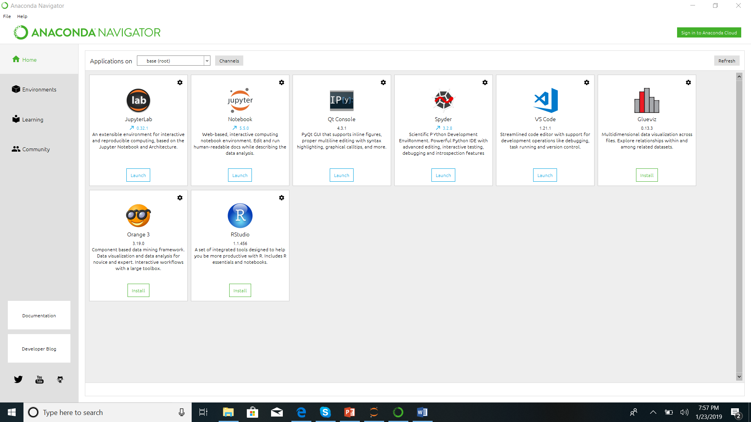

1. Anaconda navigator can help a lot. Click on “jupyter notebook” to install.
2. You can create new virtual environments.
3. Select the virtual environment where you want to install GraphViz. If you don’t want to create virtual environment, you can simply select the “base” environment.

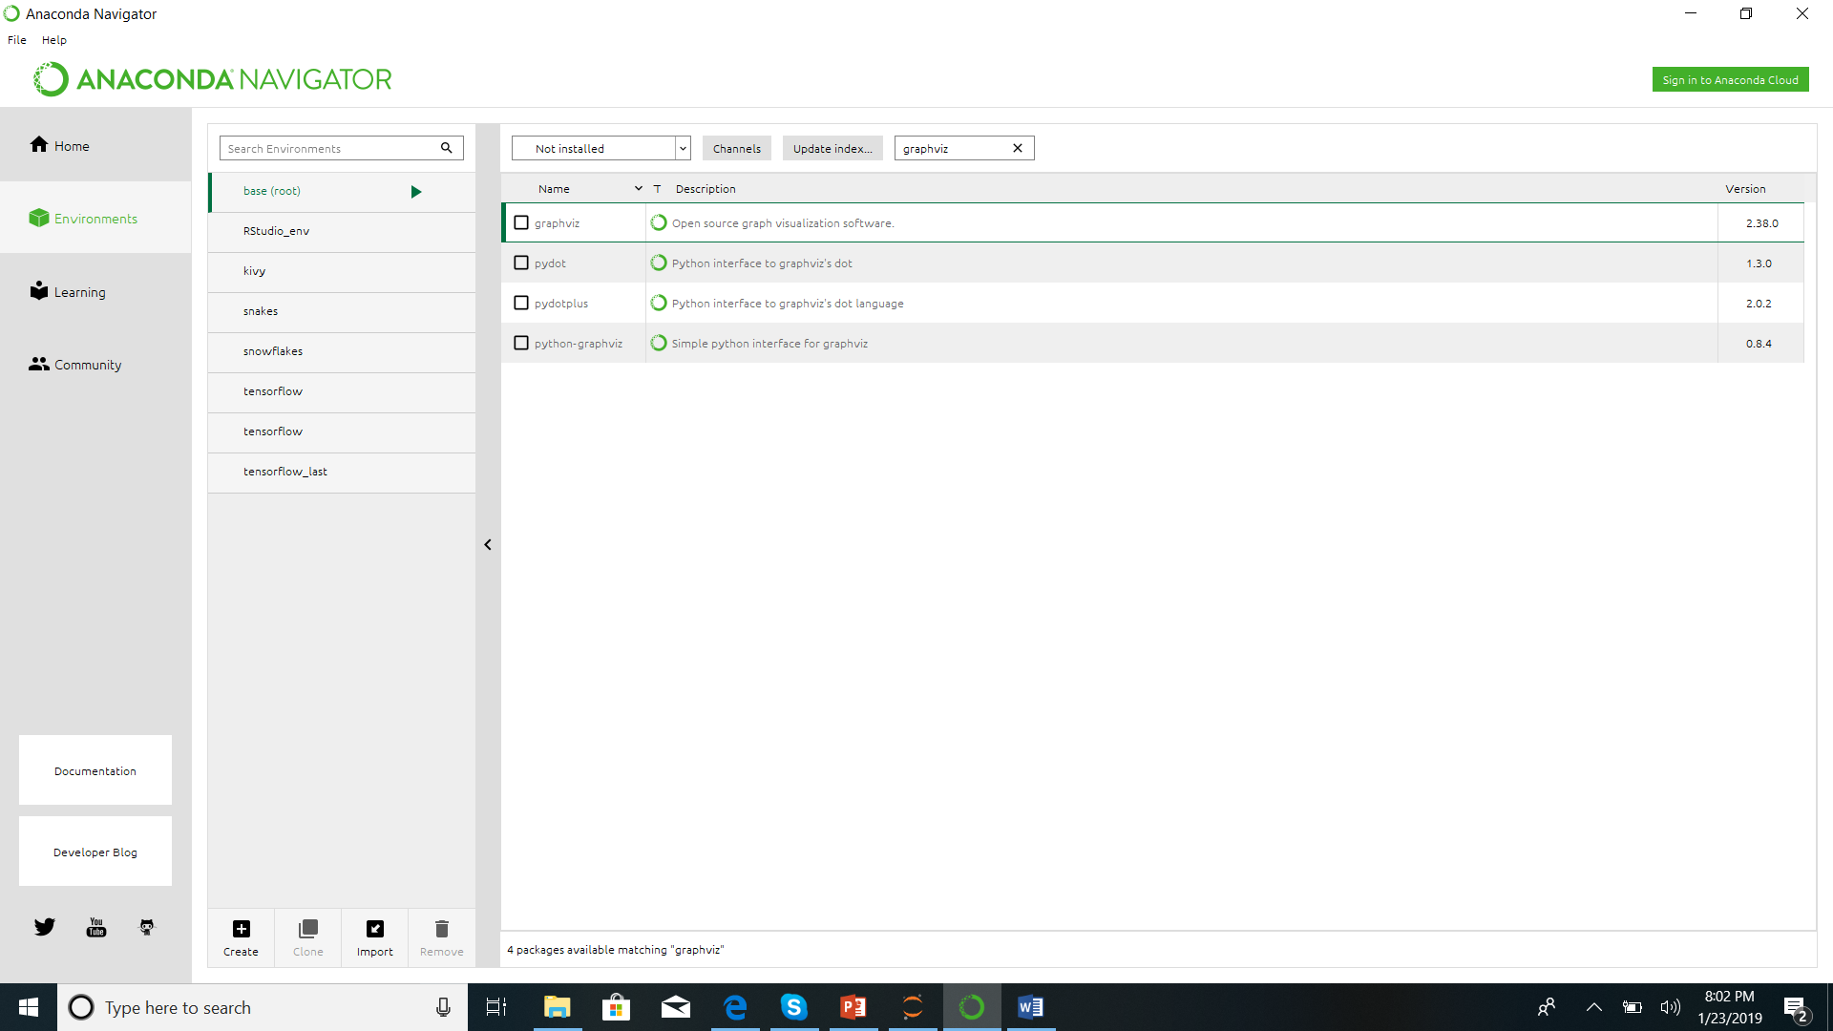

Select “Not Installed”

Write “graphviz”

Check all the options

Select environment

1. Press “apply” button on the right corner. It will install all the necessary packages and dependencies for you. If there is a prompt to ask you to install the other packages, press “yes”. It will take a few minutes and will install graphviz package.
2. How to check “graphviz” is installed or not?. Use import graphviz in the code and you should not get error.
3. I run the following code and it works.

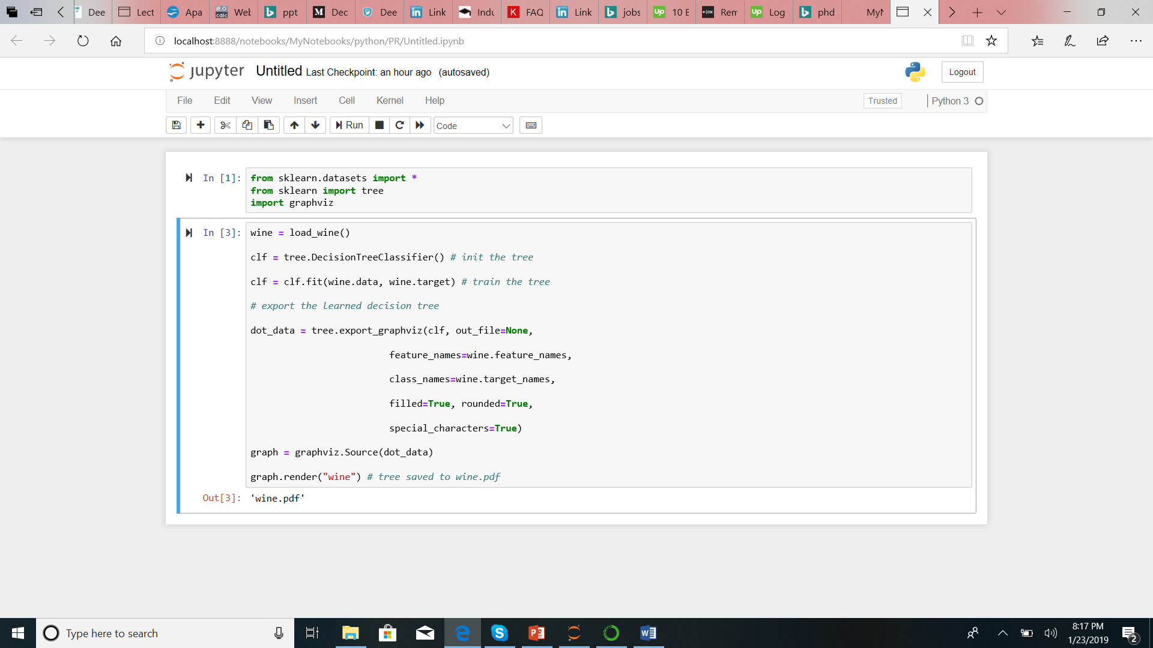

1. The decision tree is saved in pdf file.

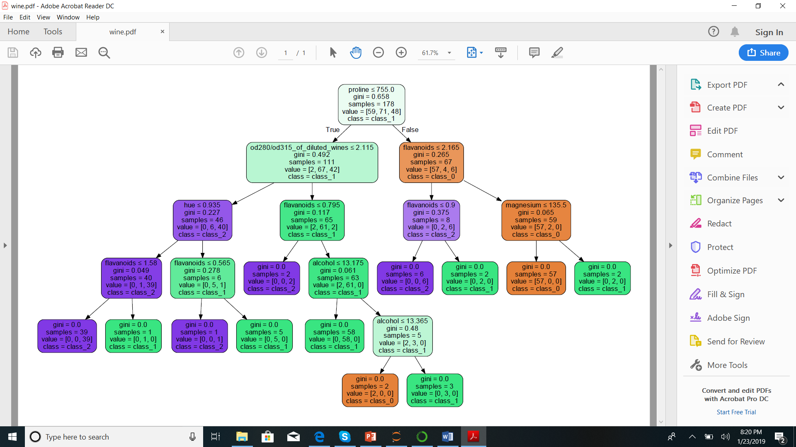

1. I hope this will help you to complete the homework.